**ASSIGNMENT-4**

**WOKWI SIMULATION**

|  |  |
| --- | --- |
| Assignment Date | 08-11-2022 |
| Student Name | SILVIYA.X |
| Student Roll Number | 737819ECR177 |
| Maximum Marks | 2 Marks |

# QUESTION:

Write a code and make a connection in WOKWI for ultrasonic sensor. Whenever distance is less than 100 , send “alert” to IBM cloud and display in device recent events.

# PROGRAM:

#include <WiFi.h> #include <PubSubClient.h> WiFiClient wiﬁClient; String data3;

#deﬁne ORG "d5oxwa"

#deﬁne DEVICE_TYPE "ibm-device" #deﬁne DEVICE_ID "ibmid"

#deﬁne TOKEN "vtn5w?t3s?vX-vn8Z8" #deﬁne speed 0.034

#deﬁne led 14

char server[] = ORG ".messaging.internetofthings.ibmcloud.com"; char publishTopic[] = "iot-2/evt/data/fmt/json";

char topic[] = "iot-2/cmd/led/fmt/String"; char authMethod[] = "use-token-auth";

char token[] = TOKEN;

char clientId[] = "d:" ORG ":" DEVICE_TYPE ":" DEVICE_ID;

PubSubClient client(server, 1883, wiﬁClient); const int trigpin=5;

const int echopin=18; String command;

String data=""; long duration; ﬂoat dist; void setup()

{

**Serial**.begin(115200); pinMode(led, OUTPUT); pinMode(trigpin, OUTPUT); pinMode(echopin, INPUT); wiﬁConnect();

mqttConnect();

}

void loop() {

bool isNearby = dist < 100; digitalWrite(led, isNearby); publishData();

delay(500);

if (!client.loop()) { mqttConnect();

}

}

void wiﬁConnect() {

**Serial**.print("Connecting to "); **Serial**.print("Wiﬁ"); WiFi.begin("Wokwi-GUEST", "", 6);

while (WiFi.status() != WL_CONNECTED) { delay(500);

**Serial**.print(".");

}

**Serial**.print("WiFi connected, IP address: ");

**Serial**.println(WiFi.localIP());

}

void mqttConnect() {

if (!client.connected()) {

**Serial**.print("Reconnecting MQTT client to "); **Serial**.println(server);

while (!client.connect(clientId, authMethod, token)) {

**Serial**.print("."); delay(500);

}

initManagedDevice();

**Serial**.println();

}

}

void initManagedDevice() {

if (client.subscribe(topic)) {

// Serial.println(client.subscribe(topic));

**Serial**.println("IBM subscribe to cmd OK");

} else {

**Serial**.println("subscribe to cmd FAILED");

}

}

void publishData()

{

digitalWrite(trigpin,LOW); digitalWrite(trigpin,HIGH); delayMicroseconds(10); digitalWrite(trigpin,LOW); duration=pulseIn(echopin,HIGH); dist=duration*speed/2; if(dist<100){

String payload = "{\"Alert Distance\":"; payload += dist;

payload += "}";

**Serial**.print("\n"); **Serial**.print("Sending payload: "); **Serial**.println(payload);

if (client.publish(publishTopic, (char*) payload.c_str())) {

**Serial**.println("Publish OK");

}

}

if(dist>100){

String payload = "{\"Distance\":"; payload += dist;

payload += "}";

**Serial**.print("\n"); **Serial**.print("Sending payload: "); **Serial**.println(payload);

if(client.publish(publishTopic, (char*) payload.c_str())) {

**Serial**.println("Publish OK");

}else {

**Serial**.println("Publish FAILED");

}

}

}

# OUTPUT:

**WOKWI SIMULATION:**

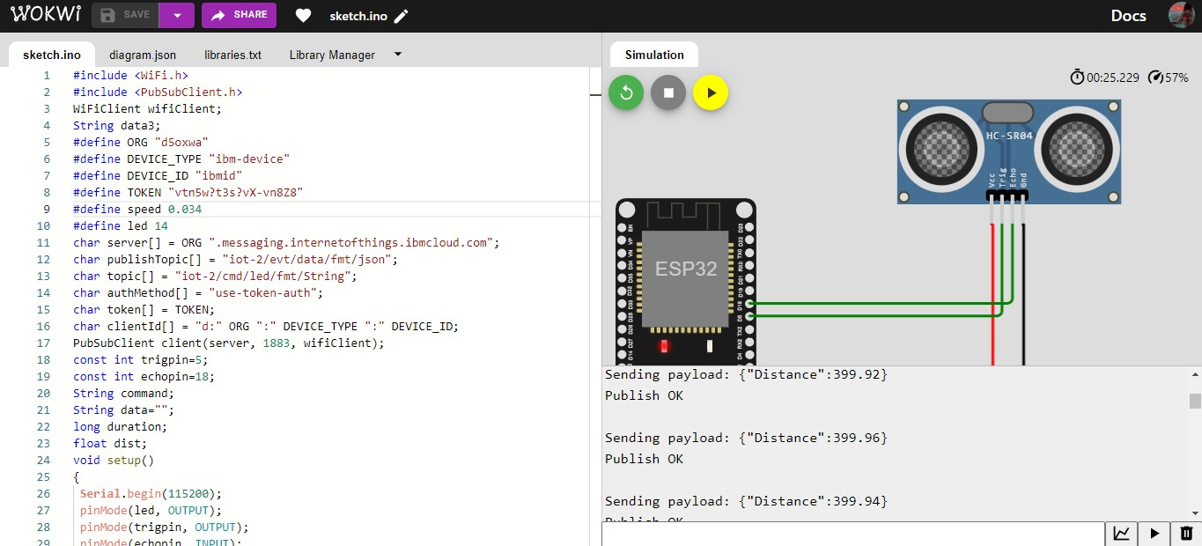

# When distance>100

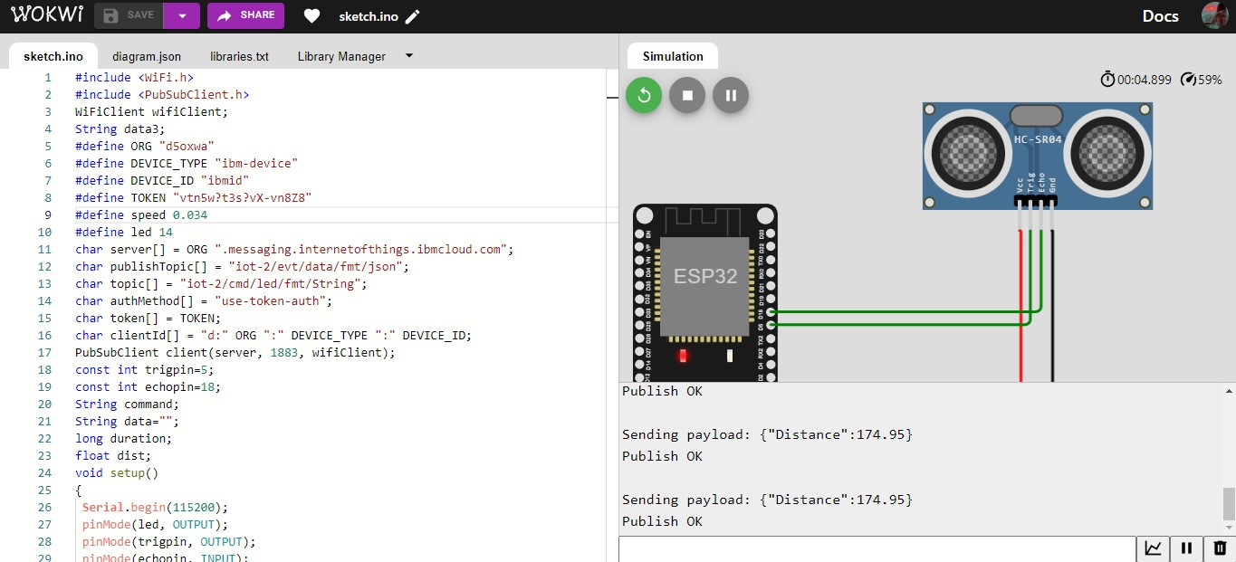

**When distance<100**

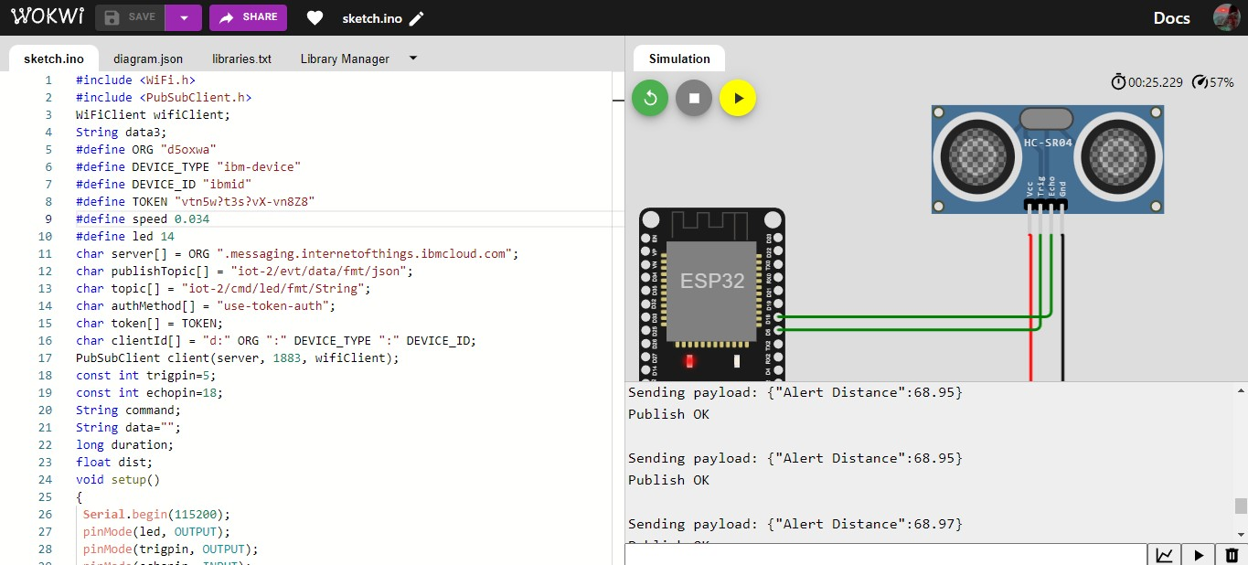

# IBM CLOUD OUTPUT:

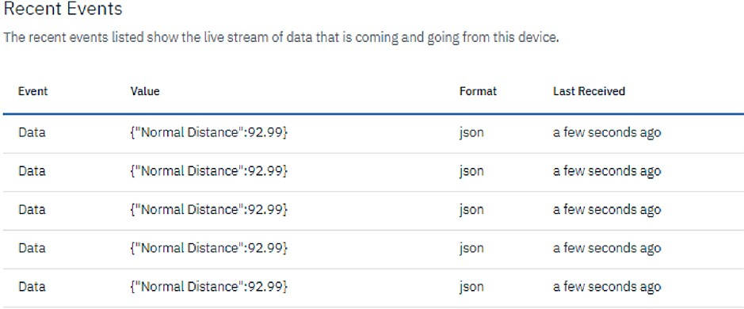

**WOKWI LINK:**

https://wokwi.com/projects/347414646073852499